Boolean Logic

* True or False

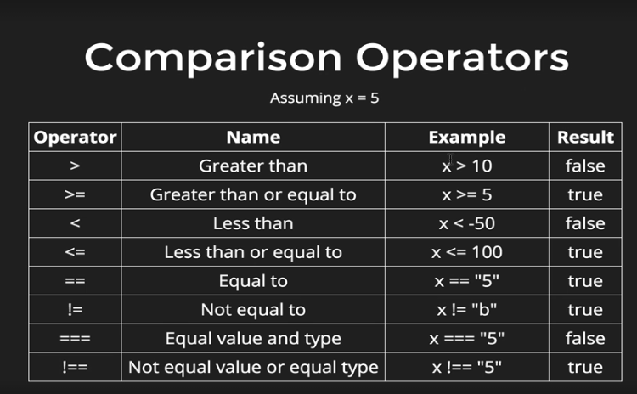

Type coercion

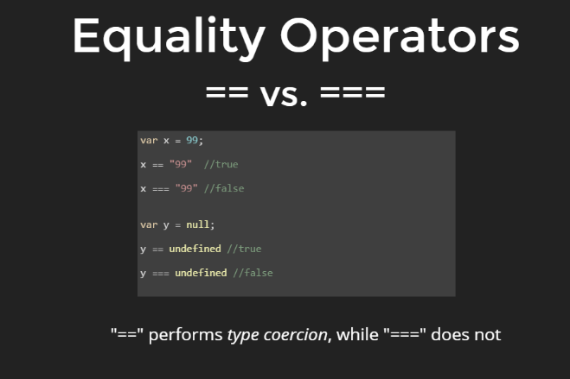

* “==”
  + Has the same value of
* “===”
  + Has the same value of and type

